Technical Rider – INFUSION BAROQUE

1. PERSONNEL
PRESENTER agrees to provide technical personnel responsible for sound equipment (microphones) and lighting. If PRESENTER does not provide a harpsichord, PRESENTER agrees to provide personnel to help load the harpsichord in and out of the performance facility. The technician will be available from the arrival of the group until the end of the concert.

2. USE OF THE PERFORMANCE FACILITY
Typical schedule as follows for a performance at 8:00 pm:
3:00 pm – 4:30 pm Installation and harpsichord tuning;
4:30 pm – 6:00 pm Dress rehearsal;
6:00 pm – 7:00 pm Dinner break;
7:00 pm – 7:30 pm Harpsichord tuning (touch-ups);
8:00 pm Concert (usually ~1.5 hours);
Tear down immediately after the concert.

3. SOUND
If possible, PRESENTER provides 2 microphones on stands to allow the musicians to speak to the audience.

4. LIGHTING
PRESENTER provides the lighting equipment needed to light the performance space with clear and homogeneous light.

5. STAGE
PRESENTER provides 3 black music stands and 4 chairs (height: 18” – 19”).

6. STAGE PLAN
The stage plan for a typical INFUSION BAROQUE performance is as follows:
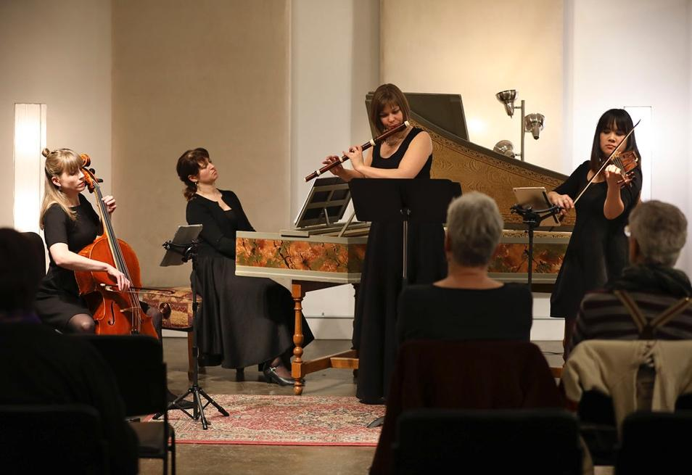

7. GREEN ROOM REQUIREMENTS
PRESENTER will provide drinking water and a light vegetarian snack.

8. DIET RESTRICTIONS AND ALLERGIES
Vegetarian: Alexa Raine-Wright, Rona Nadler
Allergic to pet dander: Sallynee Amawat

9. CONTACT
For all questions regarding technical needs:
Alexa Raine-Wright | 438 827-9170 | infusionbaroque@gmail.com

